B.W.J.N. Bandara

EU/IS/2019/PHY/76

PS2826

**TASK 3**

An Access Control List (ACL) is a set of rules used on routers or firewalls to control the flow of network traffic. It allows or denies packets based on various criteria such as source/destination IP, protocol, port number, etc.

Rule

|  |  |  |  |  |  |
| --- | --- | --- | --- | --- | --- |
| **Origin VLAN** | **Destination VLAN** | **Connection Type** | **Access** | **Origin Network** | **Destination Network** |
| Management | Finance | IP | Deny | 192.168.1.0 | 192.168.5.0 |

Before Add Deny Rule

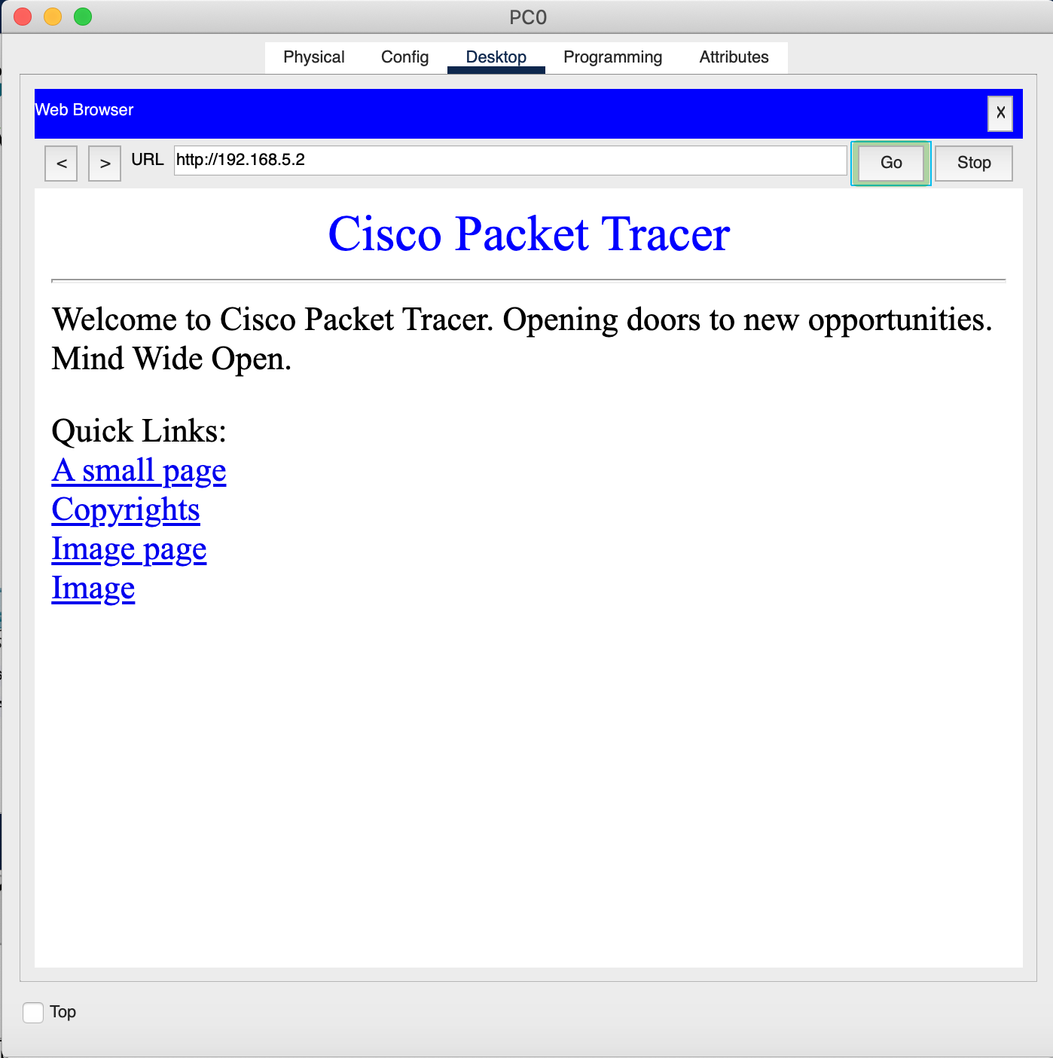

Adding Rule

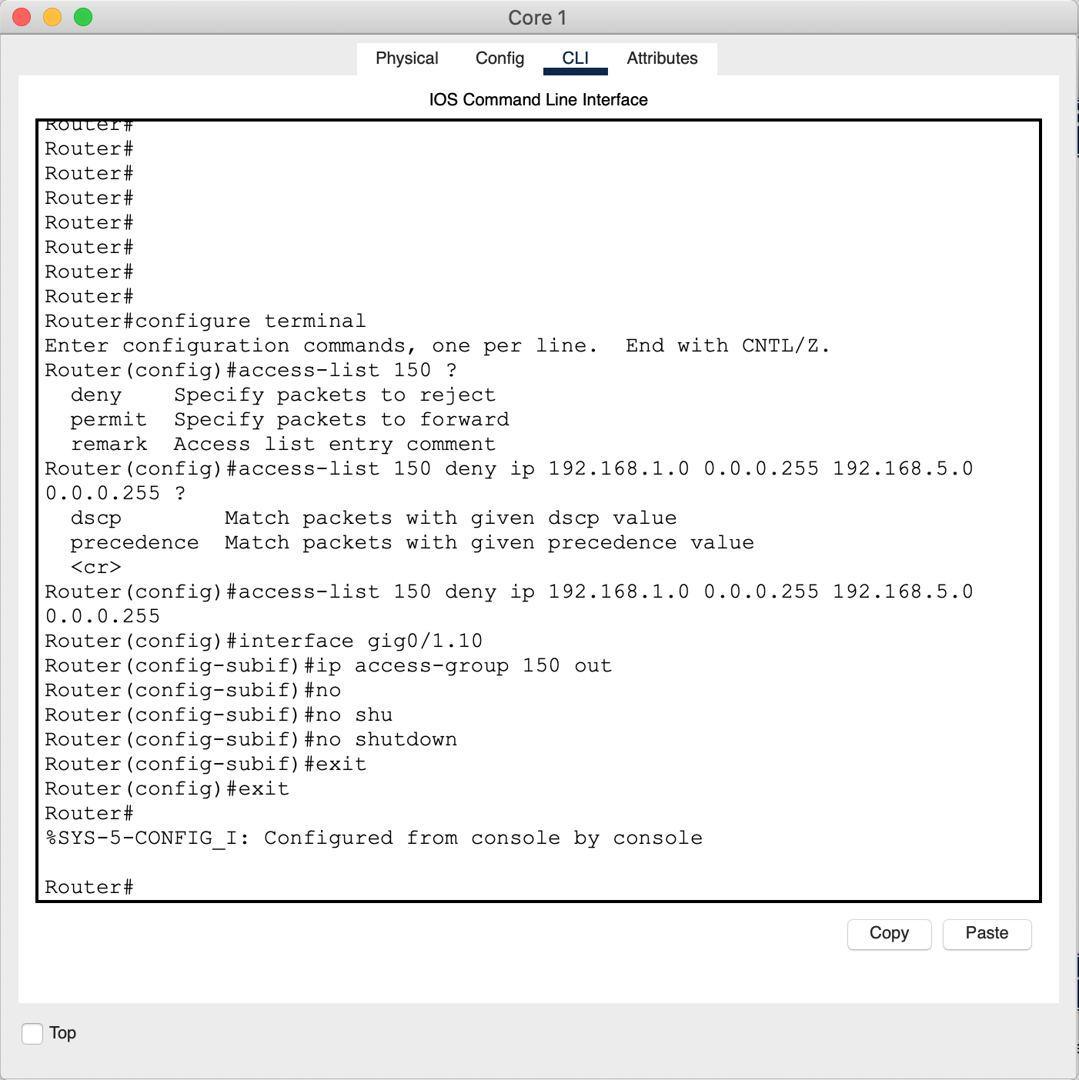

After Added Rule

